# Rekordbox prep for Titanic's End (TE)

Titanic's End is a massive and versatile sound stage with 150,000+ LEDs, lasers, and beacons. On it, you will be able to play louder and with better lights & automation than many festivals.

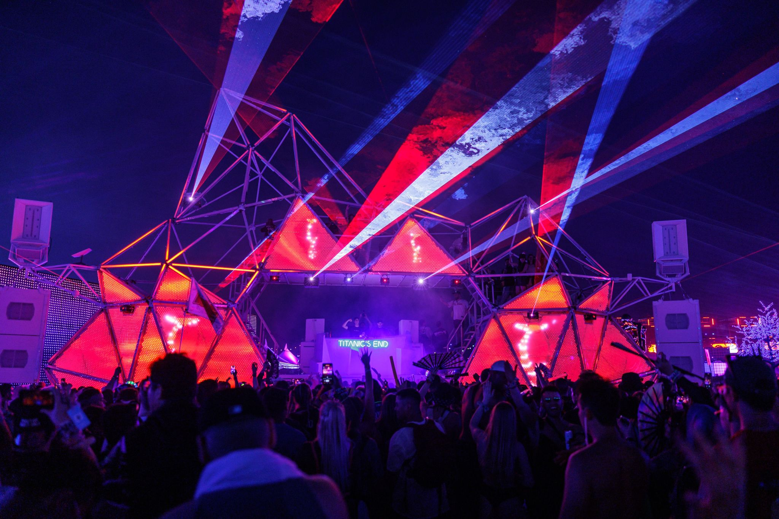

Titanic's End at EDC 2023 - Slander EDC Closing Set

Our lighting system works best when you've used Pioneer's Rekordbox software and **enabled phrase analysis. Rest assured: doing this will NOT change your beat grids, keys, or cue points!**

By default, Rekordbox analysis only includes **BPM** and **KEY**. If you add **PHRASE** analysis to your collection, your show will have visual effects sync'd to the builds, drops, and breakdowns, perfectly in time.

To be clear, **this is optional.** The visuals will still be great. But if you do use Rekordbox, it has a big impact.

And the good news: it takes roughly 60 seconds to get your tracks TE-ready!

## How to (safely) prep for your Rekordbox playlist, in 60 seconds

Rest assured: doing this **will NOT mess up your beat grids, keys, or cue points!**

### Step 1: Highlight tracks

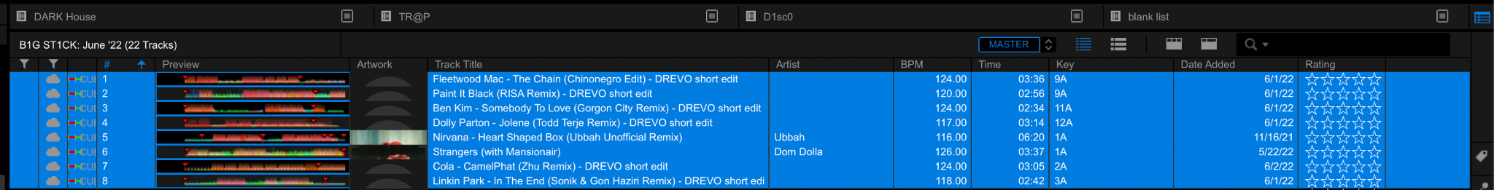

### Step 2: Turn Analysis Lock "Off"

Right click → turn Analysis Lock "Off".

If applicable. If they are unlocked, then **skip to next step.**

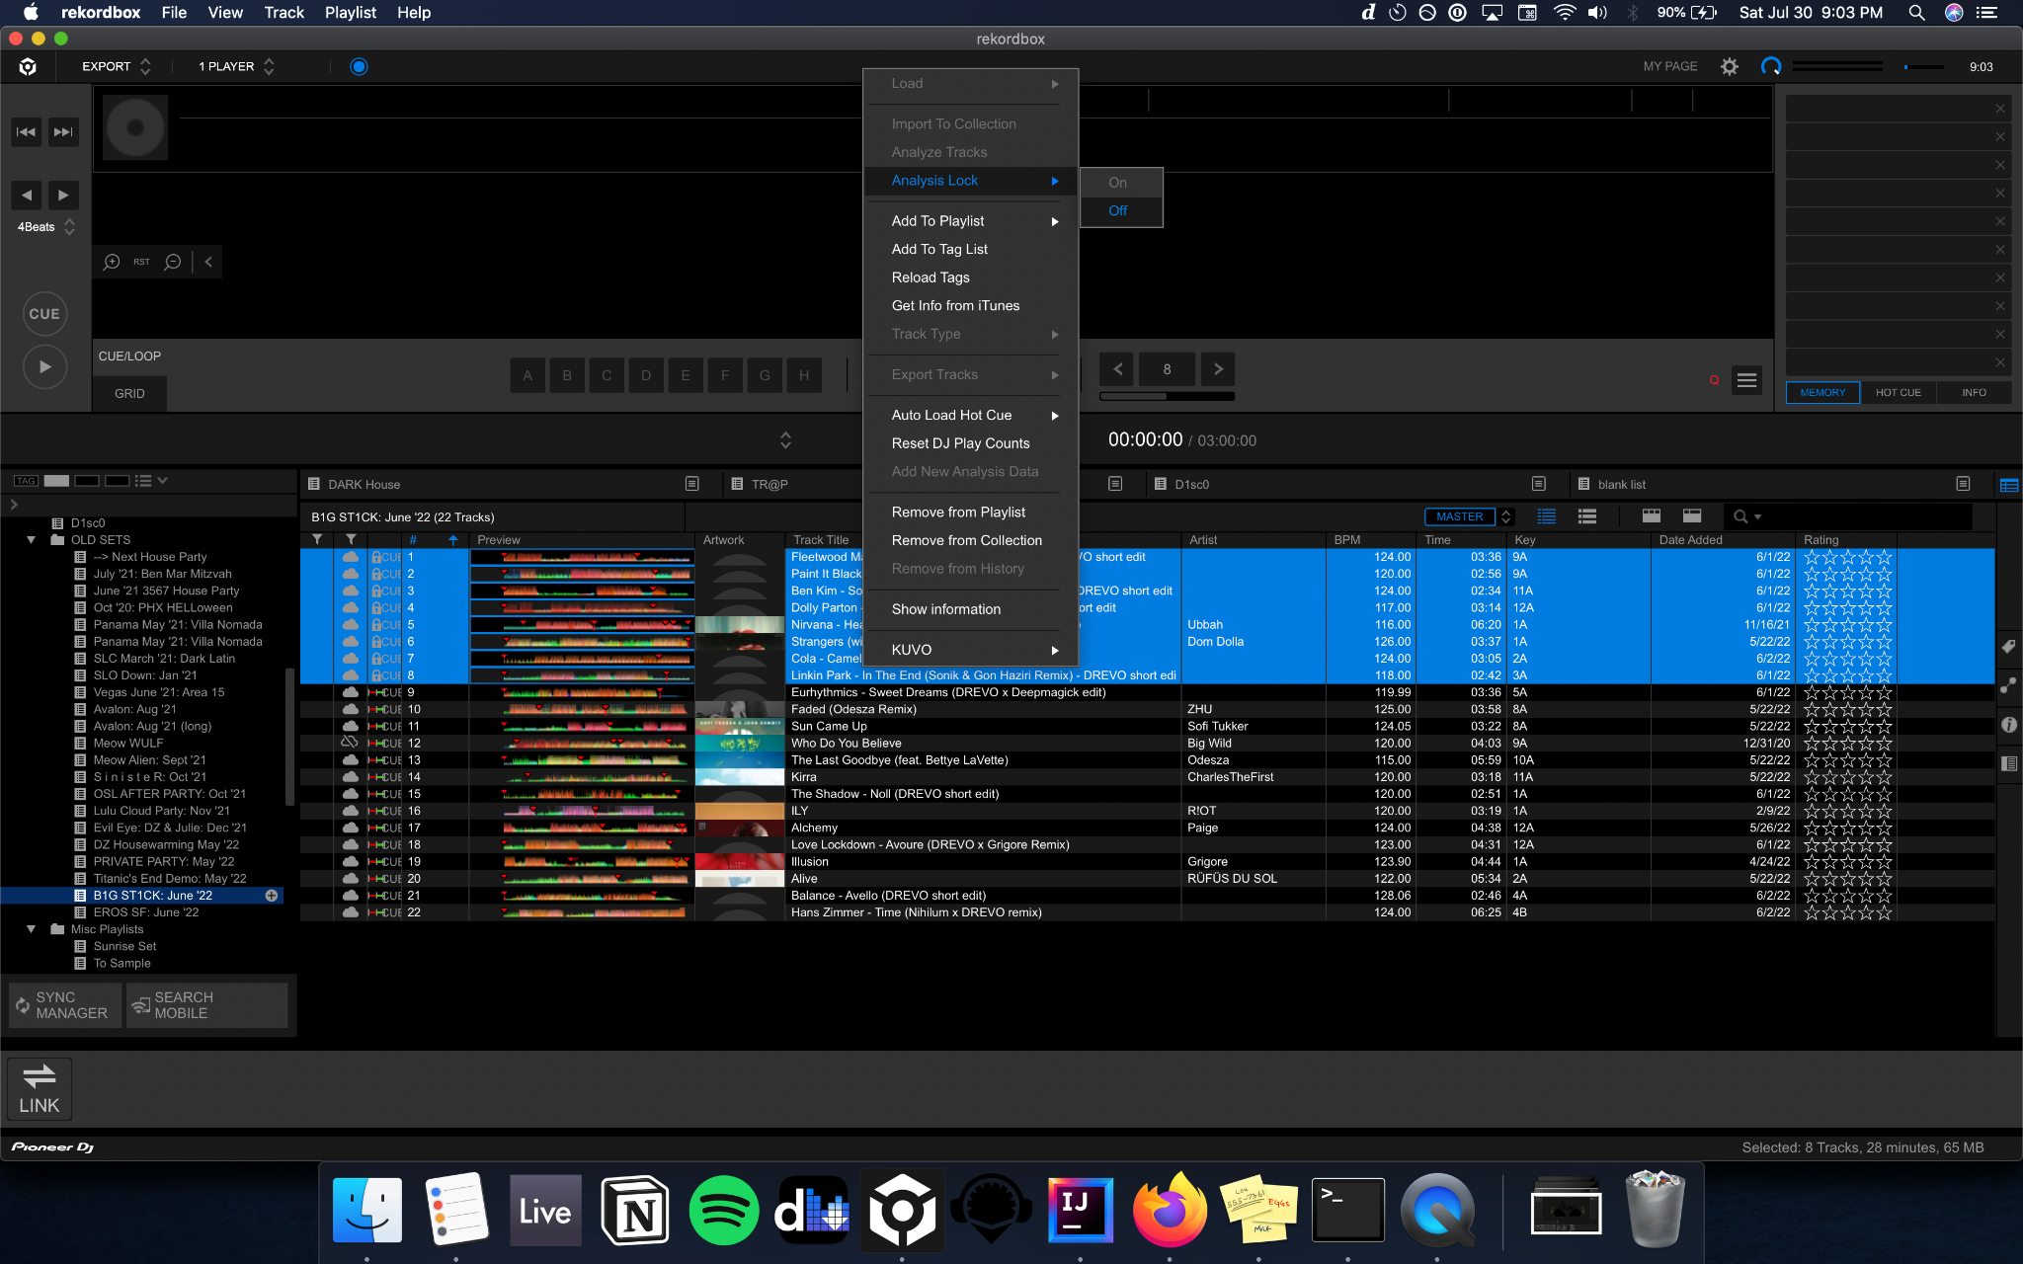

### Step 3: Analyze

Right click → Analyze.

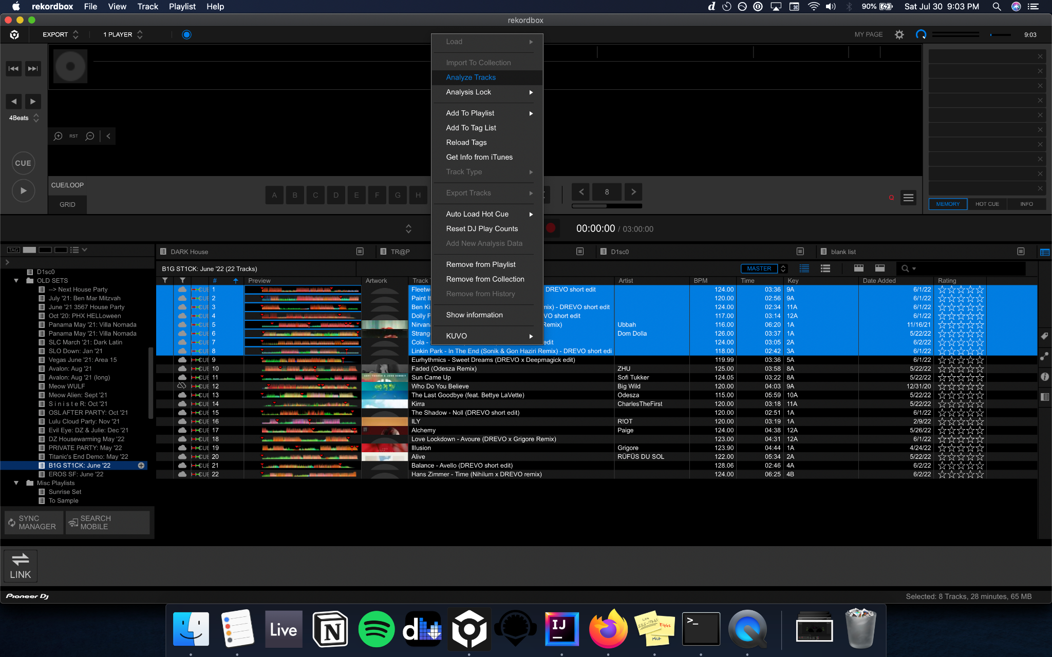

### Step 4: Select ONLY PHRASE

**Most important** step!

Don't forget, and don't accidentally select BPM or KEY, unless you want to redo those.

### 

By selecting ONLY phrase, **you won't erase or overwrite any grid or key data**.

Just click "OK". Analysis should take around 30-60 seconds, depending on how many tracks you've selected.

When you're done, in export mode, you should be able to see the phrases in place:

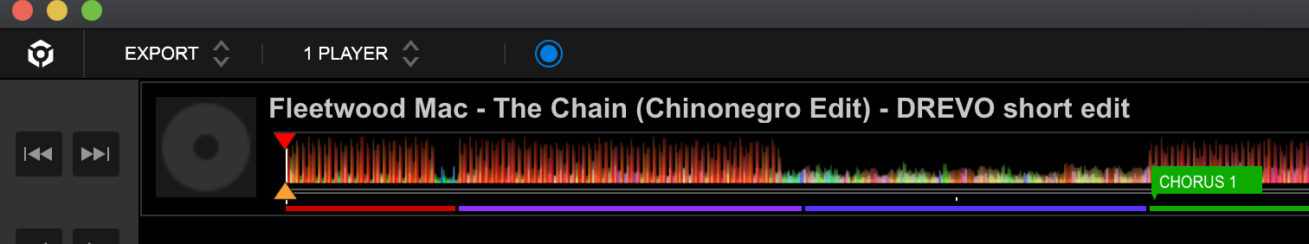

Or, in the list view you'll see a small indicator in the CUE column (the Mo Bamba edit has phrase information tagged, but the other rows here do not).

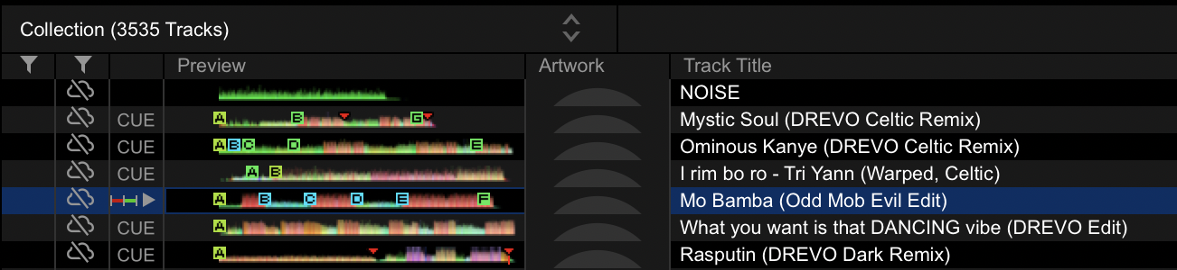

### Step 5: Analysis Lock back "ON"

Lock in these changes! This prevents any accidental changes to key, bpm, grid, or phrase data.

**THAT'S IT, YOU'RE READY TO PLAY ON TITANIC'S END!**

If you have questions, feel free to ask Will at TE ([will.drevo@gmail.com](mailto:will.drevo@gmail.com)).

We're more than happy to walk you through anything.

If you're truly a perfectionist and want to manually edit Rekordbox's phrase data, [see here](https://docs.google.com/document/d/1BKMmhSPaj3A_NqxfgpZe4o77p5KIiDUmu2lm7SEqb74/edit#), but know that this is totally optional.